**Embedded System Design PIC16f628 OBSTACLE ESCAPE ROBOT Working Principle**

Using the digital input output pins of the Pic16f268a microprocessor, the l293 motor driver IC was triggered according to the information from the HC-SR04 distance sensor. Triggered motor driver integrated 6v geared motors are enabled to turn back and forth according to the incoming trigger.

By calculating the distance perceived by the HC-SC04 distance sensor, it is aimed that the motor will rotate in the measurement below 20 cm, so that when there is an obstacle closer than 20 cm in front of it, it will not crash into the obstacles by turning.

A 9v battery is used to supply the Pic16f628a processor circuit. With the 7805 voltage regulator, this is drawn to 5v.

For the supply of the motors, 6v power was provided by using 4 AA 1.5v pen battery series connected slots.

# Used materials:

* 1 pc pic16f628 microprocessor
* 1 x l293D motor driver integrated
* 1 pcs 7805 5v regulator
* 1 HC-SC04 distance
* 2 integrated sockets
* 1pc 100uf/16v capacitor
* 1 x 100nf capacitor
* Copper plaque
* Soldering wire and soldering iron

# Characteristics of the Materials Used:

**PIC16F628 MICROPROCESSOR:**

The PIC16F628 takes its name from the initials of the English word

“Peripheral Interface Controller”. Its Turkish translation is "Peripheral Units Controller Interface". The instructions to program a PIC16F628 are very few and easy, as they are produced using a method called RISC (Reduced Instruction Set Computer) architecture. A design method plan The basic idea in RISC architecture is that it is easier and uses fewer instructions. The figure shows the external appearance of the PIC16F628.

PIC16F628, like other pics, is produced with Harvard architecture built on RISC structure and is an 8-bit microcontroller from the PIC16CXX family with flash program memory. Due to the architectural structure of the PIC16F628, the program and data memories are physically in separate units and are accessed by different data paths. The general features of PIC16F628 are shown in the table.

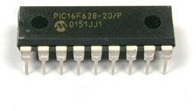

* + Clock Frequency Highest Operating Frequency 20 MHz
  + Memory Flash Program memory 2 k
  + RAM Memory 224 bytes
  + EEPOM Memory 128 bytes
  + Peripheral Units Timing (TIMER) modules TMR0, TMR1, TMR2
  + Analog Comparator 2
  + Capture\Compare\PWM Module 1
  + Serial Communication USART
  + Other Features Cutting Welding 10
  + Number of Input/Output Terminals 16
  + Operating Voltage Range 3-5.5V
  + Brown-out Detection Yes
  + Package Format 18-pin DIP, SOIC 20-pin SSOP

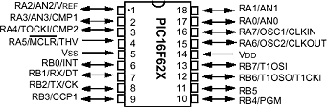

# PIC16F628 Port A

Port A is 8-bits long. Shows the explanations about the terminals of Port A.

RA0/AN0 17 I\O Bi-directional I/O terminal and analog comparator input RA1/AN1 18 I\O Bi-directional I/O terminal and analog comparator input

RA2/AN2/VREF 1 I\O Bi-directional I/O terminal and analog comparator input and VREF output

RA3/AN3/CMP1 2 I\O Bi-directional I/O terminal and analog comparator input and analog comparator output

RA4/TOCKI/CMP2 3 I\O Bi-directional I/O terminal, TMR0 clock signal input and analog comparator output

RA5/ /THV 4 I Input terminal and reset input

RA6/OSC2/CLKOUT 17 I\O Bi-directional I/O terminal and crystal oscillator output

RA7/OSC1/CLKIN 18 I\O Bi-directional I/O pin, crystal oscillator input and external clock source input

# PIC16F628 Port B

Port B is 8-bits long.

RB0/INT 6 I\O Bi-directional I/O terminal and external interrupt input

RB1/RX/DT 7 I\O Bi-directional I/O terminal, USART receiver terminal and synchronous data I/O terminal

RB2/TX/CK 8 I\O Bi-directional I/O terminal, USART transmit terminal and synchronous clock pulse input/output terminal

RB3/CCP1 9 I\O Bi-directional I/O terminal, catch compare PWM module input/output terminal

RB4/PGM 10 I\O Bi-directional I/O terminal, undervoltage programming input terminal

RB5 11 I\O Bi-directional I/O terminal

RB6/T1OSO/T1CK1 12 I\O Bidirectional I/O pin, TIMER1 oscillator output and TIMER1 clock pulse input

RB7/T1OSI 13 I\O Bi-directional I/O terminal and TIMER1 oscillator input

# L293D and L293B Motor Driver ICs

L293D and L293B motor driver ICs are 16 pin motor driver ICs containing two H bridges. With L293D and L293B, which are motor driver integrations that are generally preferred in DC motor control, two motors can be controlled independently from each other in two directions. In addition, PWM control can be made by using the enable legs of L293 motor driver integrateds.

L293D motor driver IC can be used in the range of 4.5 V to 36 V up to a maximum current limit of 600 mA. It is possible to use L293B motor driver integrated in the same voltage range, up to a maximum current limit of 1 A.

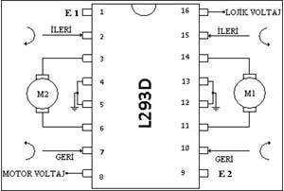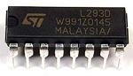

# HC-SR04 Ultrasonic Distance Sensor

The hc-sr04 ultrasonic sensor is an input source that calculates the distance to the object opposite using sonar (Sound Navigation and Ranging). The system we call sonar allows us to obtain the distance and size of the object by using sound waves. Such sensors are inspired by dolphins and bats. In them, it communicates and moves with sonar. The distance between 2cm and 400cm is the most healthy reading range. There is a receiver and a transmitter module on it.

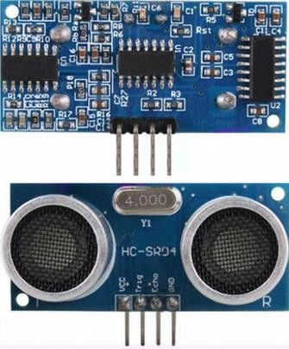

# HC-SR04 Distance Sensor Features

* Power Supply : +5V DC
* Minimum current : <2mA
* Working current : 15mA
* Operating frequency : 40 kHZ
* Effective Angle : <15 degrees
* Distance measurement : 2cm – 400cm
* Sensitivity : 0.3cm
* Trigger input pulse width : 10uS
* Dimension :45mm x 20mm x 15mm

# 6v 250 rpm Geared DC Motor

Engine Features:

Engine Features:

* Working Voltage: 3-12V
* Reduction Ratio: 1:48
* Speed: 250 Rpm(@6V)
* Current: 95mA (max. 160mA)
* Weight: 29gr

Wheel Features:

* Diameter: 65mm
* Thickness: 30mm
* Weight: 38gr

Package Included:

* 6V 250 Rpm Plastic Geared Motor
* High Quality Plastic Wheel

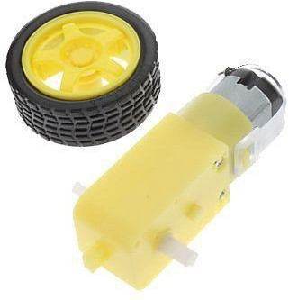

# USED DIAGRAM AND PCB DRAWING

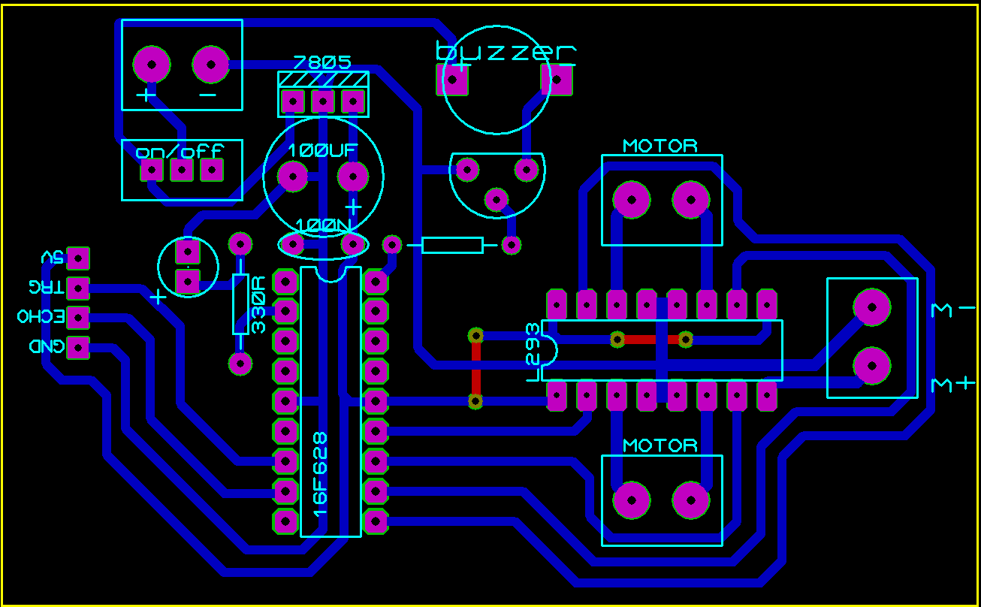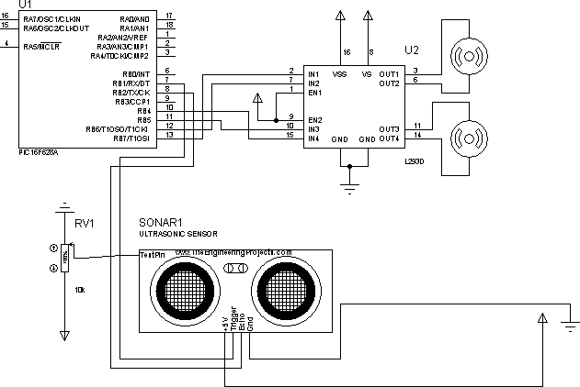

**Codes:**

#include <16f628a.h>

#FUSES NOWDT //No Watch Dog Timer #fuses INTRC_IO //Internal RC Osc, no CLKOUT

#FUSES NOPUT //No Power Up Timer

#FUSES NOPROTECT //Code not protected from reading #FUSES NOBROWNOUT //No brownout reset

#FUSES NOMCLR //Master Clear pin used for I/O

#FUSES NOLVP //No low voltage prgming, B3(PIC16) or B5(PIC18) used for I/O

#FUSES NOCPD //No EE protection

#use delay(clock=4000000)

#define trig PIN_b1 #define echo PIN_b2 #define in1 PIN_b7 // #define in2 PIN_b6 // #define in3 PIN_b5 // #define in4 PIN_b4 // void main(){

setup_timer_1(T1_INTERNAL | T1_DIV_BY_1);

set_tris_B(0b00000100);

output_b(0x00); output_a(0x00);

float mesafe,sure;

while(1)

{

output_high(trig); delay_us(10); output_low(trig);

while(input(echo)!=1 set_timer1(0);

while(input(echo)!=0 sure=get_timer1(); mesafe=sure*0.017;

if(mesafe<15) //

{output_b(0b01010000); // come down

delay_ms(500); output_b(0b00000000); // stop delay_ms(250); output_b(0b10010000); // turn delay_ms(250);

}

else

{

output_b(0b10100000); // forward command

}

}

}